- Create ansible playbook to create ansible vault.
ansible-vault create vault.yml
create password
---
db_user: myapp
db_password: S3cr3t

site.yml
- name: Demo using Ansible Vault vars
hosts: localhost
vars_files:
- vault.yml
tasks:
- name: Show DB user
debug:
msg: "DB user is {{ db_user }}"

run play book
ansible-playbook -i hosts.ini site.yml --ask-vault-pass
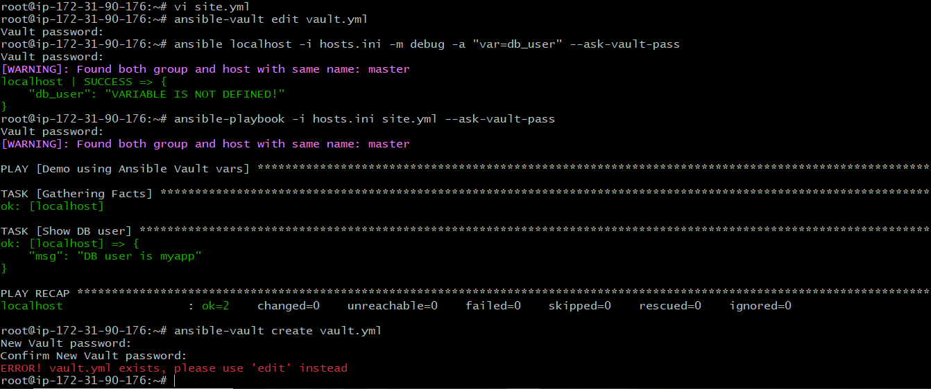
- Write a ansible playbook to install apache in linux and ubuntu machine by using when condition.
Apache.yml in the root path
- name: Install Apache on Linux/Ubuntu
hosts: all
become: true
tasks:
- name: Install Apache on Debian/Ubuntu family
apt:
name: apache2
state: present
update_cache: true
when: ansible_os_family == "Debian"
- name: Install Apache on RedHat/Amazon Linux family
yum:
name: httpd
state: present
when: ansible_os_family == "RedHat"
- name: Ensure Apache service is started and enabled (Ubuntu/Debian)
service:
name: apache2
state: started
enabled: true
when: ansible_os_family == "Debian"
- name: Ensure Apache service is started and enabled (RedHat/Amazon Linux)
service:
name: httpd
state: started
enabled: true
when: ansible_os_family == "RedHat"
- name: Deploy custom index.html page
copy:
dest: /var/www/html/index.html
content: |
<html>
<head><title>Welcome</title></head>
<body>
<h1>Apache is installed and working!</h1>
<p>Deployed by Ansible.</p>
</body>
</html>
owner: www-data
group: www-data
mode: '0644'
when: ansible_os_family == "Debian"
- name: Deploy custom index.html page (RedHat)
copy:
dest: /var/www/html/index.html
content: |
<html>
<head><title>Welcome</title></head>
<body>
<h1>Apache is installed and working!</h1>
<p>Deployed by Ansible.</p>
</body>
</html>
owner: apache
group: apache
mode: '0644'
when: ansible_os_family == "RedHat"
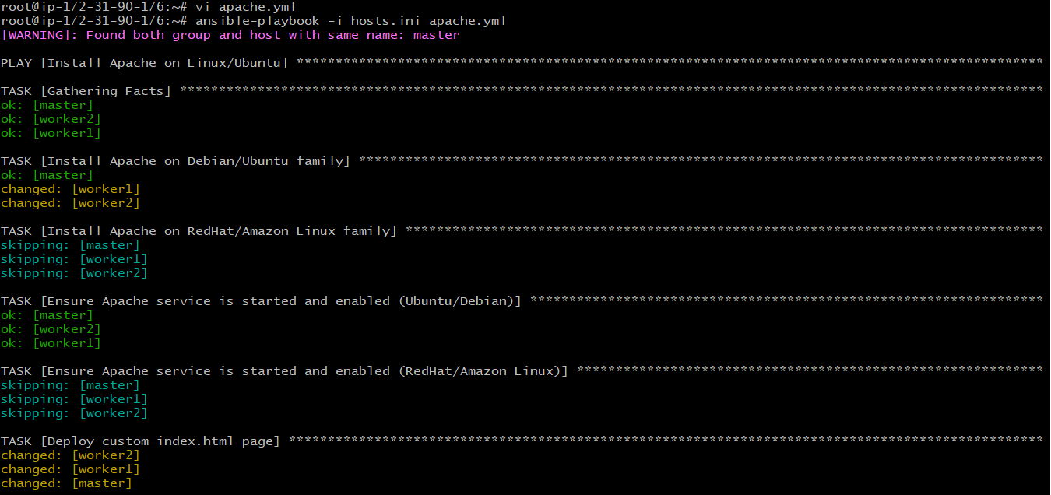
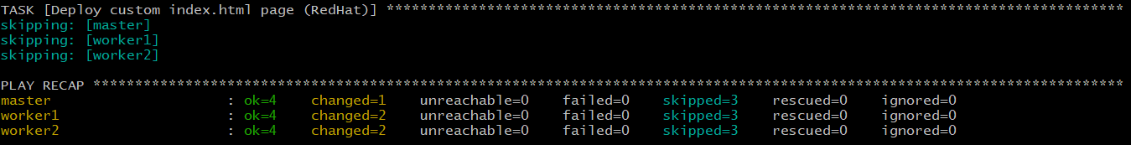
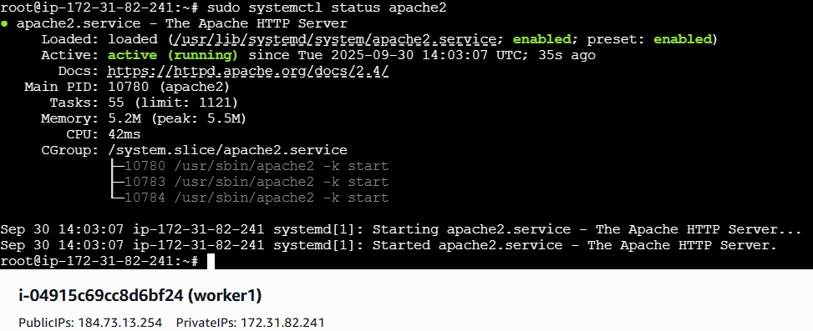
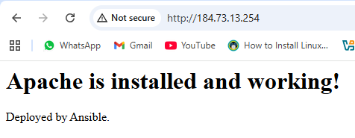
- Create ansible playbook using roles to configure LAMP stack
Launch ec2 instances: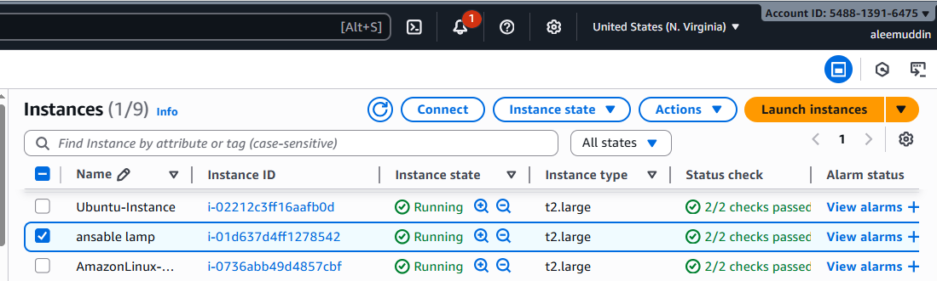
Create role:
Under below
Cd ci-terraform-ansible/ansible/ ls
ansible-galaxy init lamp
Architecture :
lamp_playbook.yml
hosts.ini
roles/
└── lamp/
├── defaults
├── files
├── handlers
├── meta
├── tasks
├── templates
├── tests
└── vars
Verify structure:
ls -R roles/lamp
hosts.ini:
[all]
172.31.28.224
172.31.17.221

Directory Structure (inside your lamp role)
lamp/
├── defaults
│ └── main.yml
├── tasks
│ └── main.yml
├── templates
│ └── index.php.j2
├── handlers
│ └── main.yml

🔹 lamp_playbook.yml
---
- name: Configure LAMP stack on all nodes
hosts: all
become: yes

pre_tasks:
- name: Fix broken dpkg on Debian/Ubuntu if needed
command: dpkg --configure -a
become: yes
when: ansible_os_family == "Debian"
ignore_errors: yes

roles:
- lamp

🔹 tasks/main.yml (inside lamp role)
---
# ==========================
# Apache installation
# ==========================

- name: Install Apache on Ubuntu/Debian
apt:
name: apache2
state: present
update_cache: yes
when: ansible_os_family == "Debian"

- name: Install Apache + PHP modules on RHEL/CentOS/Amazon Linux
yum:
name:
- httpd
- mod_ssl
- php
- php-mysqlnd
state: present
when: ansible_os_family == "RedHat" or ansible_distribution == "Amazon"

- name: Ensure web root exists
file:
path: /var/www/html
state: directory

# ==========================
# MySQL / MariaDB installation
# ==========================

- name: Install MySQL (Ubuntu/Debian)
apt:
name: mysql-server
state: present
update_cache: yes
when: ansible_os_family == "Debian"

- name: Install MariaDB (RHEL/CentOS)
yum:
name: mariadb-server
state: present
when: ansible_os_family == "RedHat" and ansible_distribution != "Amazon"

- name: Install MariaDB (Amazon Linux)
yum:
name: mariadb105-server
state: present
when: ansible_distribution == "Amazon"

# ==========================
# PHP installation
# ==========================

- name: Install PHP packages on Ubuntu/Debian
apt:
name: "{{ item }}"
state: present
update_cache: yes
loop:
- php
- libapache2-mod-php
- php-mysql
when: ansible_os_family == "Debian"

# ==========================
# Deploy test page
# ==========================

- name: Deploy PHP test page
copy:
dest: /var/www/html/index.php
content: |
<?php
phpinfo();
?>
mode: '0644'
notify: restart apache

# ==========================
# Service handling
# ==========================

- name: Ensure Apache service is started and enabled (Debian/Ubuntu)
service:
name: apache2
state: started
enabled: yes
when: ansible_os_family == "Debian"

- name: Ensure Apache service is started and enabled (RHEL/Amazon)
service:
name: httpd
state: started
enabled: yes
when: ansible_os_family == "RedHat" or ansible_distribution == "Amazon"

- name: Ensure MySQL/MariaDB service is started and enabled
service:
name: "{{ 'mysql' if ansible_os_family == 'Debian' else 'mariadb' }}"
state: started
enabled: yes

# ==========================
- name: Open HTTP service in firewalld
firewalld:
service: http
permanent: yes
state: enabled
immediate: yes
when:
- ansible_os_family in ["RedHat"]
- ansible_distribution != "Amazon" # skip on Amazon Linux

🔹 templates/index.php.j2
<?php
phpinfo();
?>

🔹 handlers/main.yml
---
- name: restart apache
service:
name: "{{ 'apache2' if ansible_os_family == 'Debian' else 'httpd' }}"
state: restarted
Master node:
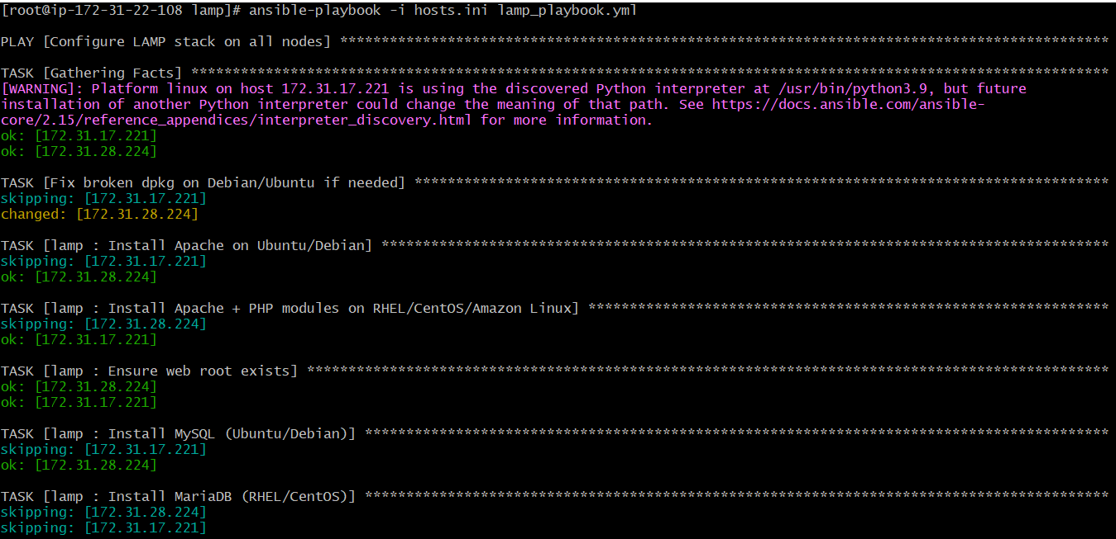
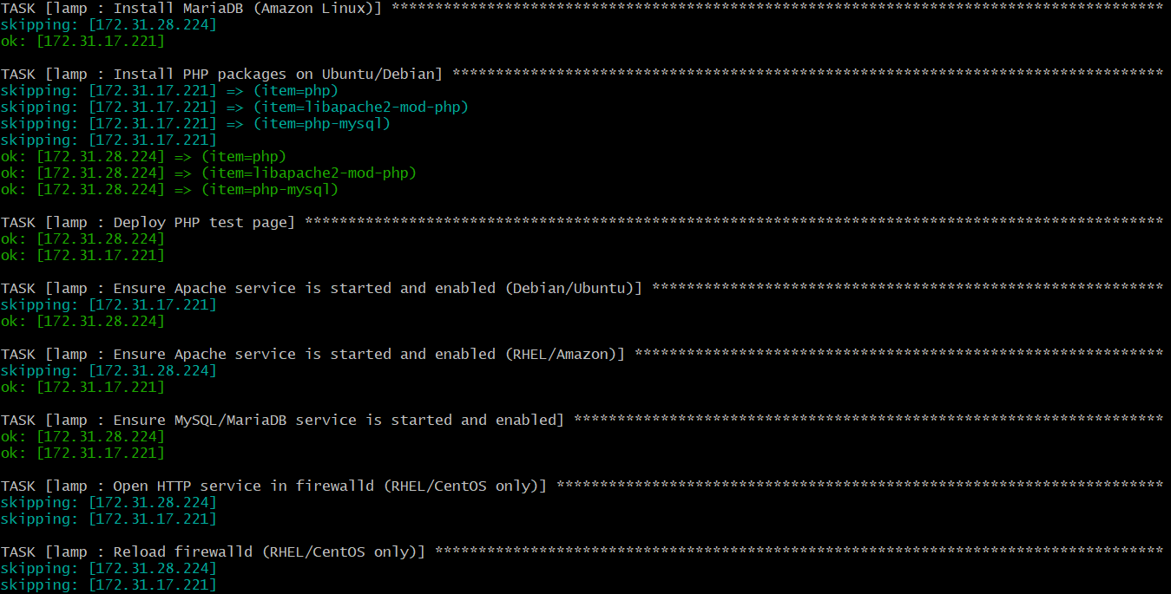
Node 1:
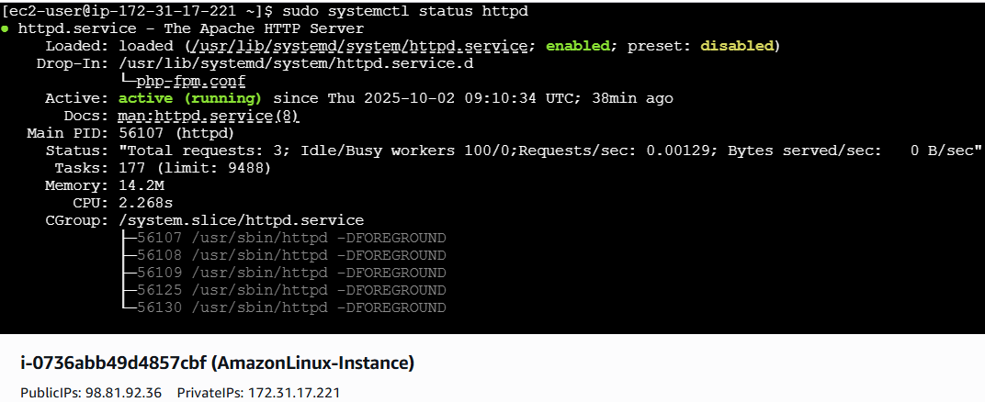
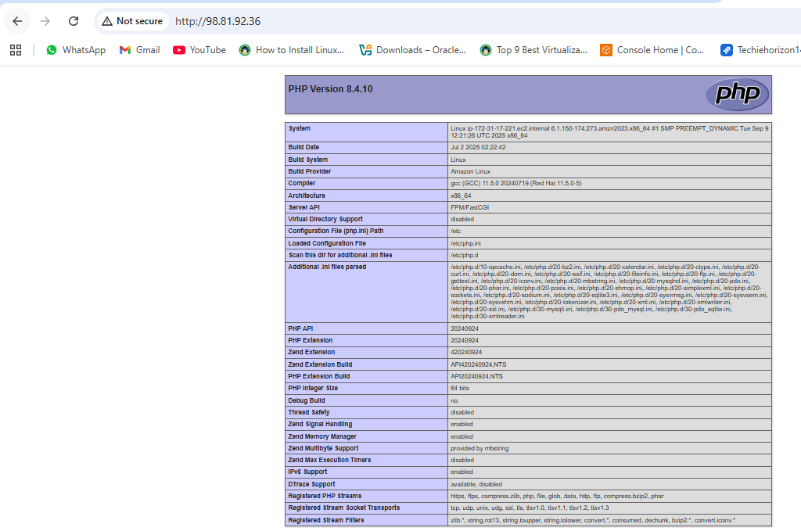
Node 2:
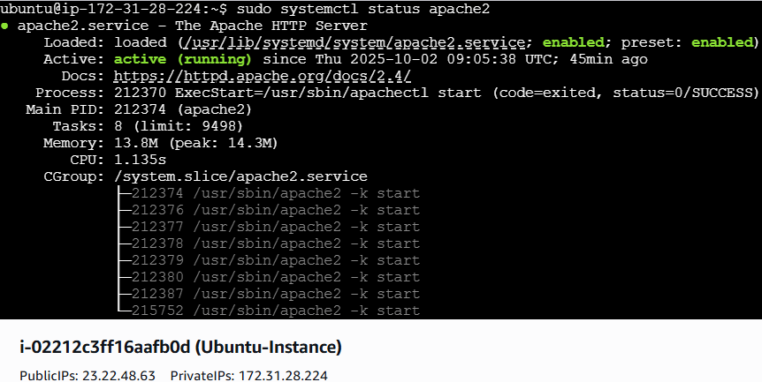
Sudo echo "<?php phpinfo(); ?>" | sudo tee /var/www/html/info.php
Then test on browser
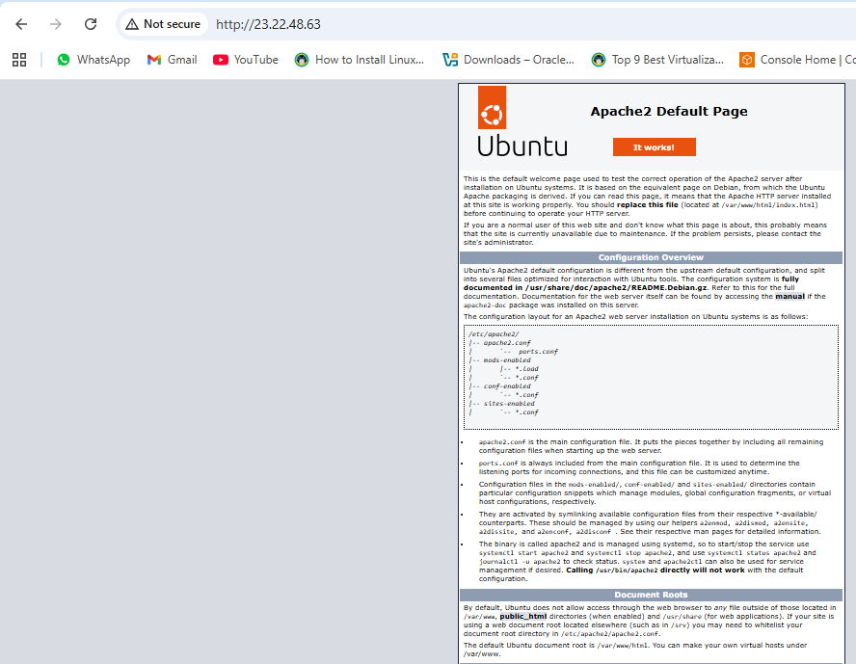
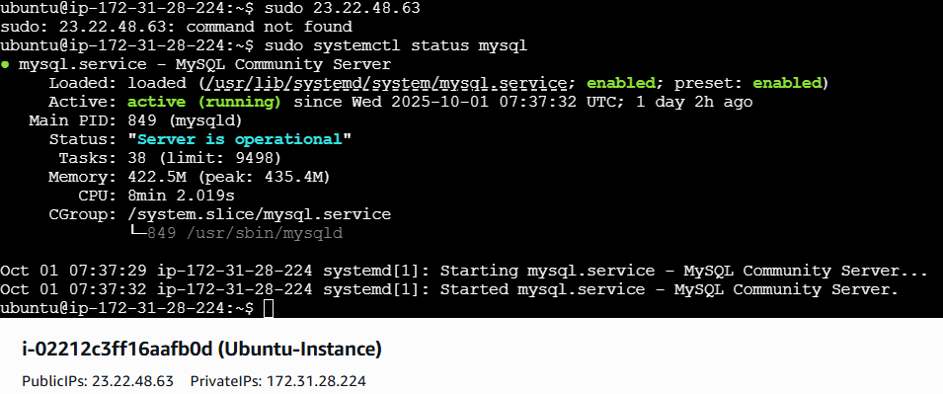
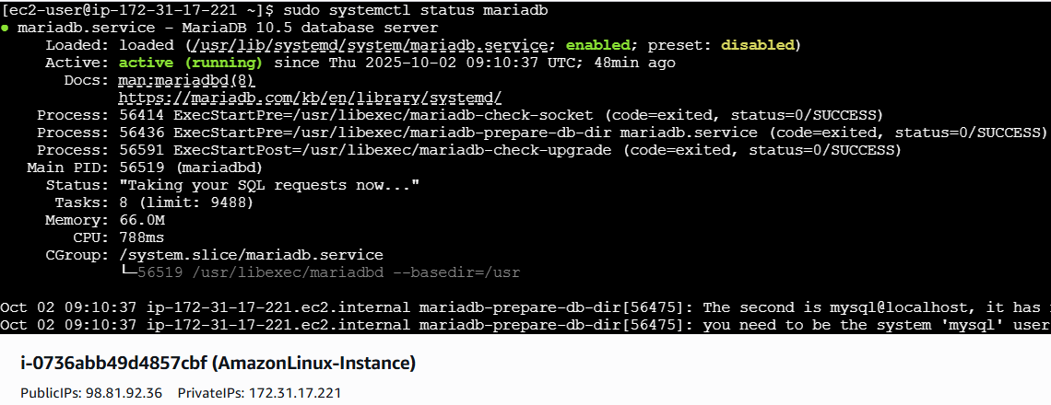

- Setup ansible AWX and explore the options.
Launch one ec2 instance
Instance type t2.large
20 gb size
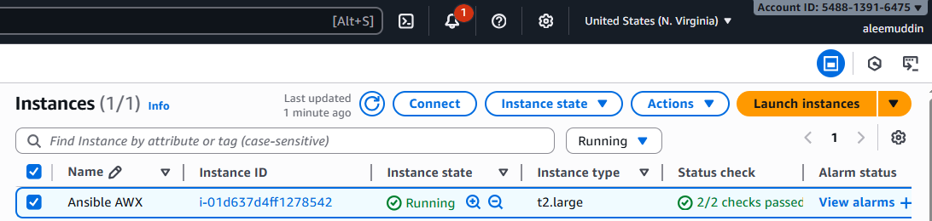

Steps to Install Docker

1. Update system
sudo yum update -y

2. Install Docker

Amazon Linux 2:
sudo yum install -y docker

3. Start and enable Docker
sudo systemctl start docker
sudo systemctl enable docker
sudo systemctl status docker
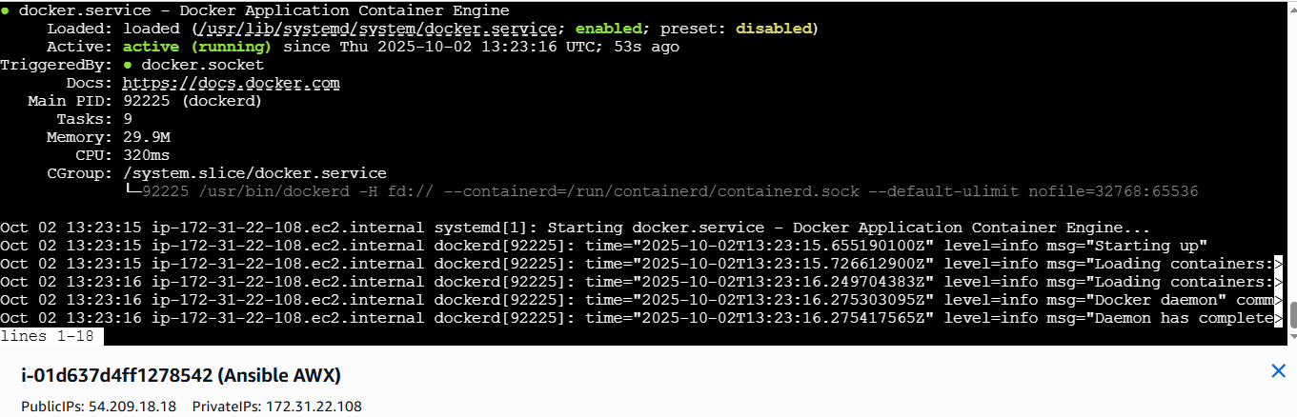
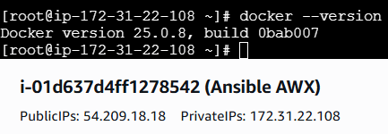

Install Docker Compose
Run these commands:
# Download latest docker-compose binary
sudo curl -L "https://github.com/docker/compose/releases/latest/download/docker-compose-$(uname -s)-$(uname -m)" \
-o /usr/local/bin/docker-compose

# Make it executable
sudo chmod +x /usr/local/bin/docker-compose

# Verify
docker-compose --version
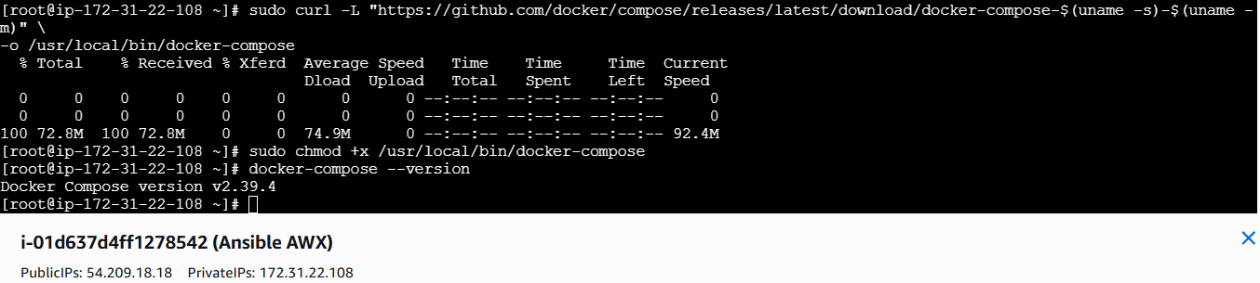

Fix: Reset the admin password
Run this inside the AWX web container:
docker exec -it awx_web bash
Then reset the password with:
awx-manage changepassword admin
- Enter the new password when prompted (e.g., Admin@123)
- You should see confirmation: Password changed successfully for user admin.
Then exit the container and try logging in again in your browser.
💡 Optional tip: You can also create a new superuser if needed:
awx-manage createsuperuser
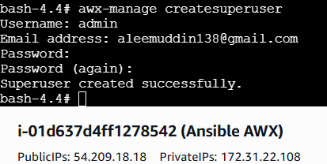
Open your browser and go to:
http:// 54.209.18.18
Enter user & password to login AWX
